Welcome to Mendoza
Argentina
MENDOZA

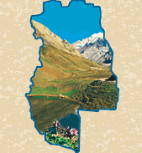

Situated at the foot of The Andes, Mendoza is the capital city of the homonymous province and the most important city of the West of Argentina. It is one of the most chosen tourist destinations because of the various interesting activities available in the region.

The city is well laid out and almost everything worth visiting is well within walking distance.

You come to Mendoza for the wineries, the excellent Argentinean food, the Andes, the friendly people, the local shopping and for the affordable pricing.
It is an incredible oasis to grow fruits and vegetables due to the presence of the Mendoza and Tunuyán Rivers.

Within an hours drive there are several hundred wineries - mostly appointment only, and the specialty here is Malbec. The Andes are a bit further but what a drive you can find on the International Route 7 towards the Chilean border. As you near the high pass, you drive by a viewpoint of Aconcagua the world's highest mountain outside of the Himalayas. The Andes are Mendoza's outdoor playground and you can find skiing, trekking, rafting and other adventure activities in Mendoza's backyard.

History
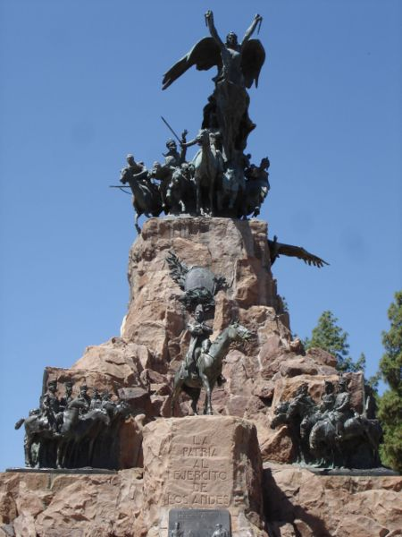
Land with historic tradition, Mendoza keeps many memories of San Martín's epic in the cerro de la Gloria (Hill of the Glory), El Plumerillo, San Martín Park and the museums that show documents testifying the presence in the region of this Argentinian eminent person.
With the arrival of the Spaniards, the territory of Mendoza was occupied by the Huarpe Indians, in the Uco Valley, North and Northwest, the Incas at Uspallata and the Mendoza River Valley and the Puelches to the South of the Mendoza River. Later on, between the XVIII and XIX centuries, the Pehuenches entered these territories, especially at the Malargüe district.
The Huarpes stand out because they had developed a net of irrigation channels in the Huentota Valley (city of Mendoza today), which enabled them to grow potatoes and corn.
The Spaniards found this clever system, which they later called "Dique de la Toma de los españoles" (Spanish Capture Dam).
The Huarpes were a peaceable, sedentary and agricultural people. Their clothes consisted of two calicos: one, from the waist to the knees and another one on the shoulders, fastened over the chest with a cactus thorn. Some women would ornament their clothes with guanaco furs tied over their shoulders or fastened around their waists.
They also wore long necklaces.
On March 2, 1561, Pedro del Castillo founded the city and named it Mendoza after the governor of Chile, Don García Hurtado de Mendoza.
A new expedition in charge of Captain Juan Jufré, attempted to eliminate what Del Castillo had done and, as he had found a more competent site, moved the city to the left margin at "two harquebus shots" to the Southwest on March 28, 1562, and renamed it "Resurrección - Provincia de Huarpes". However, time and facts were overcome and the name of Mendoza was respected.
The establishment of the Spaniards in the place, who generally resided in Chile, was so difficult that 4 years after Mendoza was founded only 12 Spaniards remained.
The governor of Chile took drastic measures, such as withdrawing economical support given to the grocers that would not get established. Therefore, the settlement started to increase and in the year 1600, the population reached some 80 Spanish settlers.
The willingness and gentleness of the indians enabled the grocers to become established, but some Spaniards moved the indians into Chile. For such reason, indian manpower was affected and finally replaced by slaves.
Two years after the foundation, the Cabildo received the powers to distribute the lands.
Thus, the first farms and vegetable gardens located around the built-up area started to appear.
From that moment on and during the XVII century, the evangelizing and cultural labor of the Jesuits started, and the following century, a whole series of political-administrative changes that would affect the region's development would take place.
Agricultural production recorded by chroniclers and travelers during the XVI century continued its development during the XVII and XVIII centuries.
We have pointed out the origins of agriculture in the primitive farms and vegetable gardens watered by indian irrigation channels. As cultivation spread, new irrigation courses were outlined, to such extent that by the XVIII century there were eighty three channels, with waters from the Mendoza and Tunuyán Rivers.
In 1776, with the creation of the Río de la Plata Viceroyalty, the political structure was modified, and in 1783 Cuyo became part of the Gobernación de Córdoba del Tucumán, being the Marquis of Sobremonte appointed provincial governor.
Not until 1788 could an irrigation work over the river be performed.
The agricultural and cattle-raising population gave origin to a significant industrial activity. Wines, brandy, dry fruit, flour and oil constituted the main lines derived from agriculture.
In the early XVIII century, Mendoza's trade with other provinces was making progress. Wine, brandy and olive oils were taken to Buenos Aires. On those days, commercial transportation was done in wooden carts, covered with leather awnings with walls of reeds or straw.
In 1813, the state of Cuyo was created and General José de San Martín became Governor.
In Mendoza, in the XIX century, preparations for the epic liberating achievement were made by the General José de San Martín, which would eventually manage independence from Spain, providing major autonomy.
In January 1817, San Martín left Mendoza and led its army across the Andes to liberate Chile and Perú.
Destroyed by an earthquake on March 20, 1861, Mendoza was re-built and, during the following century, became the regional metropolis of Cuyo, with an important commercial, industrial, financial and cultural development.
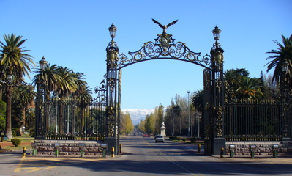

Climate
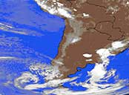
The climate of the region is mild though the mountains provide a certain degree of aridity. The temperature in Summer ranges from 18º C to 33º C and days are hot and nights are fresh. In Winter, the minimum temperature is 3º C and the maximum registered temperature is 16º C.

Population
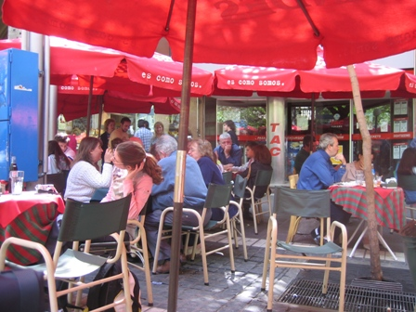
Argentina´s current population is more than 36 million inhabitants. The total population of Mendoza Province is around 1,700,000, of which approximately 800,000 reside in the city area. Population density calculated on a national basis is 13 inhabitants per square kilometer.

Architecture and urban structure
Mendoza’s architecture does not possess a defined style, but you could say it is a modern style due to the earthquake in 1861. The new city of Mendoza with all of its buildings was reconstructed and constructed from the year 1870 forth. . In the urban city square there are tall buildings but these never exceed the 8 or 10 storey high because this zone is prone to seismic waves. The type of construction is earthquake-proof, which means that more iron and of higher caliber is used than that of common constructions. Brick and reinforced concrete is also implemented.

Like most cities in Argentina, Mendoza's outdoor cafes, tree-lined walkable streets & avenues and many plazas attest to the city's European heritage. Unique to other large cities in Argentina is the exposed stone ditches (small canals) which run alongside many of the roads supplying water to the many trees that provide welcome shade.
The city is centered around the Plaza Independencia with pedestrianized Sarmiento street running through its center. Other major streets, running perpendicular to Sarmiento, are 9 de Julio St., San Martín Avenue, and running parallel to Sarmiento are avenues Colón, Arístides Villanueva and Las Heras. Many small parks, known as "plazas" are spread within the city.

Language
Spanish is the official language of the Argentine Republic. English is often understood by storekeepers and businesspeople operating in Mendoza. The language is mandatory in high school education.

Religion
There is complete religious freedom in Argentina, although the official religion is Roman Catholic. Other religions practiced in the country are Protestant, Jewish, Moslem, Greek Orthodox, Russian Orthodox and others.

Government and Constitution

Argentina consists of 23 provinces plus a federal district, the City Buenos Aires. The Argentine Constitution establishes a Republic under a representative and federal system, and three separate branches of government: executive, legislative and judicial. The executive branch is exercised by the President and Vice-president of the Nation, elected for a 4-year term, and who may be reelected for a single additional term. The legislative branch is bicameral: the Senate (composed of three senators from each province and from the City of Buenos Aires) and the House of Representatives (composed of representatives elected directly and in proportion to each district’s population). The judicial branch "is vested in the Supreme Court and lower courts of justice". Each province has adopted its own Constitution in accordance with the National Constitution, to rule its administration. The current National Constitution dates from 1853. Nevertheless, it was amended in 1860, 1898, 1957 and 1994. The last amendment made in August 1994, allows the President’s reelection for an additional term…

Two important dates
May 25, 1810. The first "Gobierno Patrio" or National Government Assembly of Argentina was constituted. July 9, 1816. Proclamation of Independence by the "Provincias Unidas del Río de la Plata"

National emblems
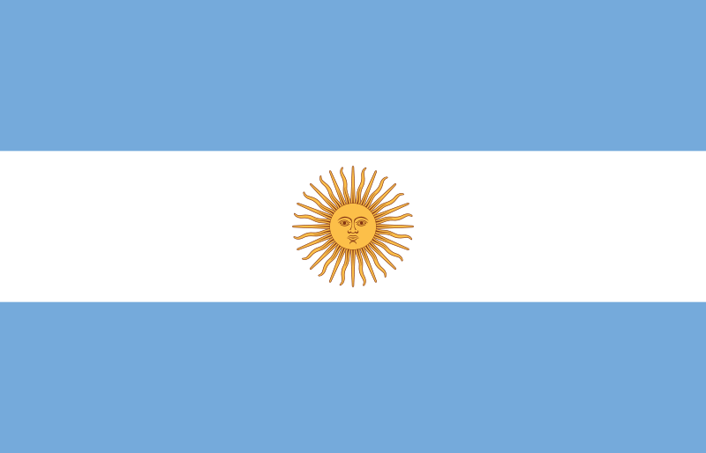
The Argentine flag has three horizontal stripes: the one in the middle is white and bears the golden sun, and the two outside stripes are light blue. The national flower is the ceibo, and the national stone is the manganese spar (rodocrosita) or "Inca Rose".

Time Zone
Argentina has only one time zone, and it is four hours behind GMT

Documents and formalities
Valid passport with or without visa depending on your nationality. Inquire at the closest Embassy or Consulate. Visitors coming from countries not bordering Argentina are exempt from all taxes on traveling articles and new articles up to US$ 300 and an additional US$ 300, if purchased at duty free shops within the national territory. No vaccination certificate is required to enter the country.

VAT return
At the airport you may obtain a VAT reimbursement corresponding to any purchases made within the country for an amount over $70 (per invoice) and in shops operating with the "Global Refund" system.

Payment methods
Although US Dollars are generally taken everywhere, foreign currencies can be exchanged in banks and authorized bureaus. American Express, VISA, Diners and Master Card are widely accepted. There may be difficulties in changing travelers check.

Opening hours


As with other Argentina cities the Siesta time is a big part of every weekday. Typically shops and most restaurants will close sometime between the hours of 1 and 2pm and reopen again starting around 4:30 to 5pm until 8 or 9pm. If you are not from a country that practices the Siesta, this can put a crimp in your eating and shopping habits for the first few days.
Restaurants often start to fill up around 10pm and reach their height of popularity around 11pm. We recommend eating a small breakfast, lunch around 1 or 2pm and then head to the restaurants around 9pm when they open and you will beat the dinnertime rush which typically starts around 10pm.

Tips
10% of the amount of the check is usually left in cafeterias and restaurants. Doormen, porters, and ushers in cinemas and theatres are also generally tipped.

Getting to Mendoza
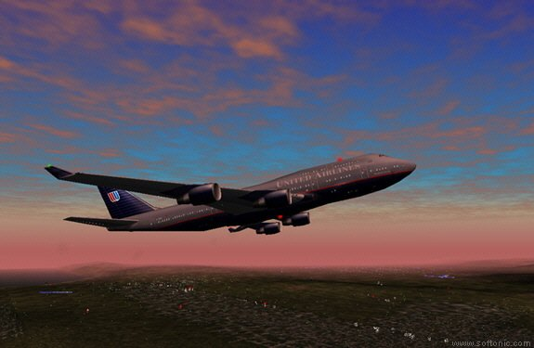
You can get to Mendoza:
via Buenos Aires
via Santiago de Chile.
from the South of Argentina (e.g. Bariloche and Ushuaia)
from the East of Argentina (e.g. Iguazú, Rosario, San Luis and Córdoba)
from the North of Argentina (e.g. Jujuy, Salta, Tucumán and Catamarca)

The distance between Buenos Aires and Mendoza is 1100 km (or 690 miles) and you can cover it by air or road. All flights from Buenos Aires to Mendoza depart from the domestic airport Jorge Newbery, and not from the international airport Pistarini, better known as Ezeiza (EZE).

Whereas flying from Buenos Aires to Mendoza takes only about 1 hour and 40 minutes, travelling by road equals a trip of somewhere between 12 and 14 hours. The coaches on that route have various 'classes' and services, both comparable to categories and services referring to air travel.

The distance between Santiago de Chile and Mendoza is 450 km (or 280 miles) and can also be covered by air or road.

Crossing the Andes on a plane gives you the opportunity of enjoying an incredible view of its highest peaks: the Aconcagua, the Mercedario and the Tunpungato. The flight takes only 45 minutes, combining a spectacular panorama with a considerable saving of time.

Crossing the Andes by road, from Santiago de Chile to Mendoza, takes about 6 hours, depending on customs controls and the condition of the international tunnel. The breathtaking landscape, including a view on the Aconcagua, makes the trip by coach or car a unique experience, too. However, if you plan to take this route, you should always bear in mind the climatic conditions. In winter, it is quite likely that the pass is closed for up to several days, due to the quantity of snow.

